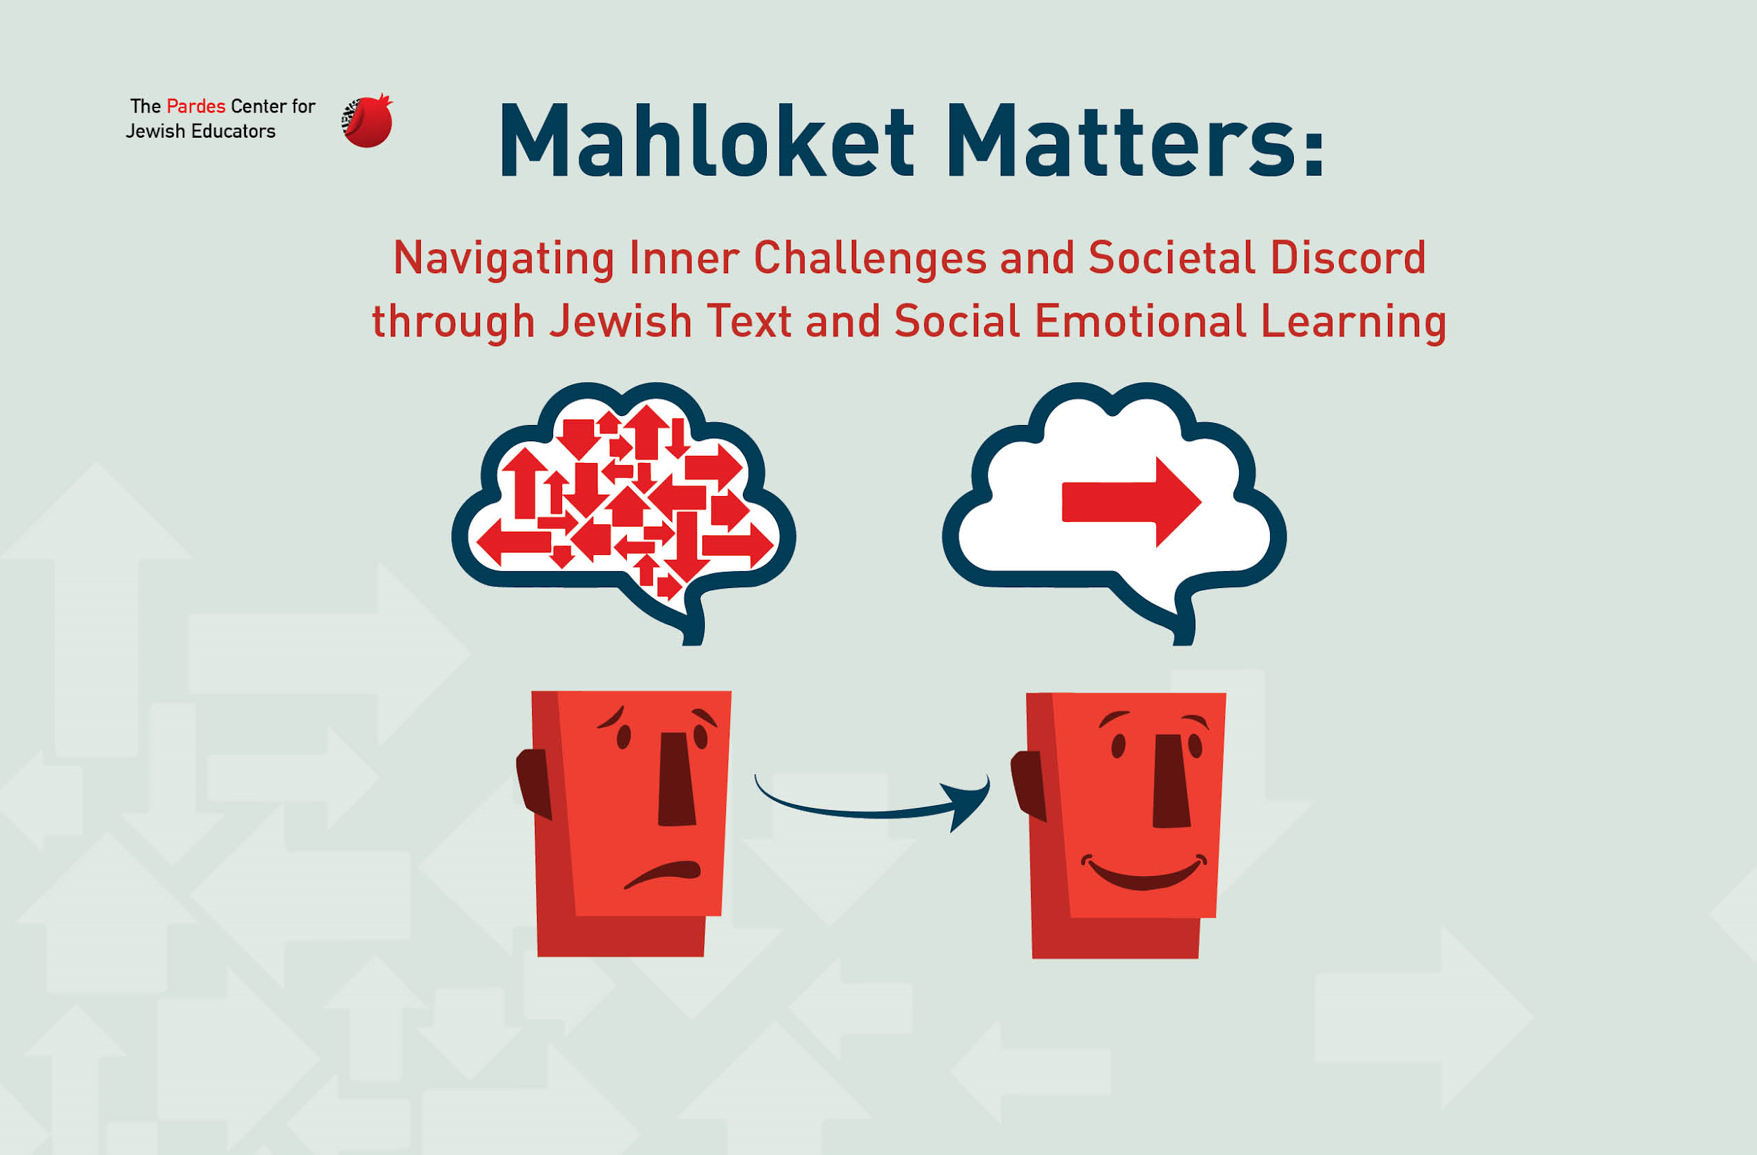

Welcome to Unit 1 of the Pardes Mahloket Matters program!

Unit 1 is called “Introduction to Mahloket Matters” and consists of the following 3 lessons:

- “The Value of 49/49”
- “Two Types of Mahlokot”
- “Understanding Ourselves and Others”

Each lesson includes Jewish texts, discussion questions, activities, and skill building. By the end of this unit, you will have explored the following essential questions:

- What is the point of interacting with people who disagree with me?
- What distinguishes a disagreement for the sake of Heaven from a disagreement not for the sake of Heaven?
- Why do good people sometimes disagree with each other on moral issues?

Lesson 1: THE VALUE OF 49/49

ACTIVITY: “Where do I stand?”

Consider the 2 statements below and follow the instructions provided by your teacher.

Statement 1:
Democracies grow STRONGER when there is disagreement among citizens.

Statement 2:
Democracies grow WEAKER when there is disagreement among citizens.

Text Study: Midrash Psalms, 12 (text 1.1)
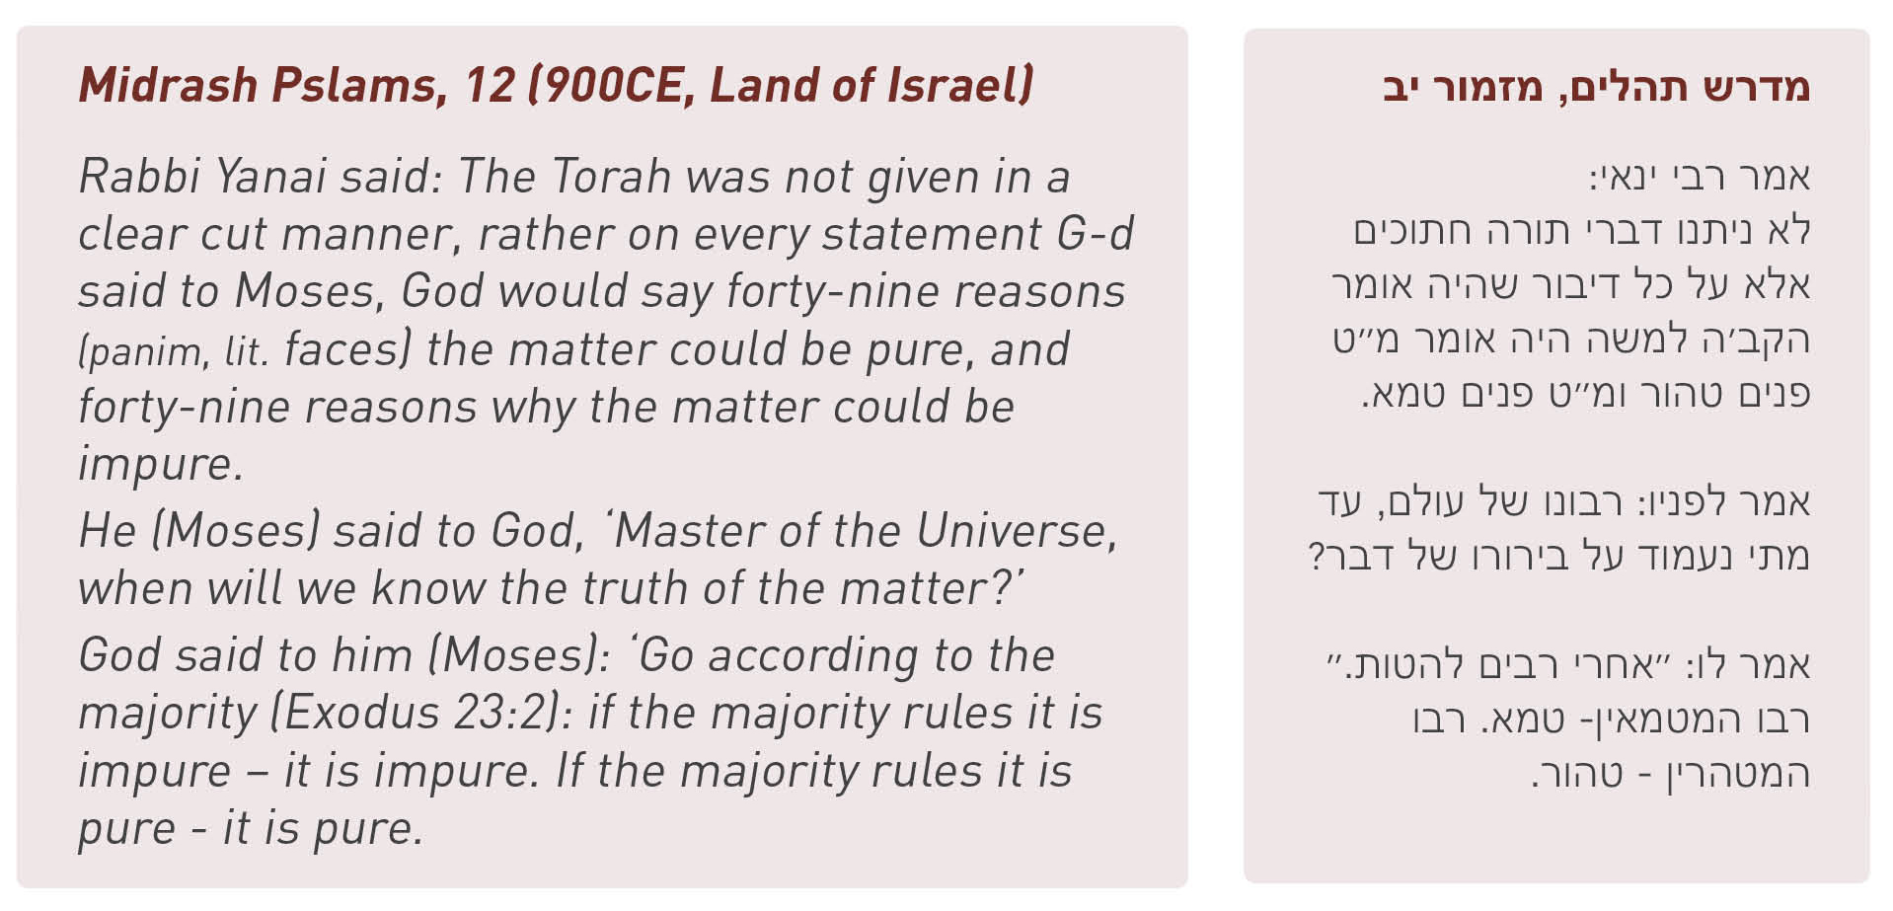
Discussion Questions
- According to this midrash, God intentionally gave the Jewish people a Torah that was NOT clear cut. Why?
________________________________________________________________________________________________________________________________________________________________________

- What word(s) would you use to describe how Moses is feeling when he poses his question to God? Why do you think Moses is frustrated?
________________________________________________________________________________________________________________________________________________________________________

- It is clear from this text that God values debate and wants us to consider opposing views before ultimately voting on a course of action. But WHY does God think that a person must bother to talk to someone with whom they disagree before deciding on a course of action?
________________________________________________________________________________________________________________________________________________________________________

ACTIVITY: “Seeing Double”

What is the 1st thing you see in each of the slides that your teacher is putting up on the screen?

- Slide #1 - ___________________________
- Slide #2 - ___________________________
- Slide #3 - ___________________________

ACTIVITY: “Considering the Other 49”

Instructions
- Read the “would you rather” questions in the left column of the chart below.
- For each “would you rather” question, silently circle or highlight your preference between the 2 options in the question.
- Write 2-3 reasons in the chart that support your preference (eg., I would rather be a wizard than a superhero, because superheroes are never allowed to take vacation).
- Several students who selected different sides of the same “would you rather” scenario will present their case to the rest of the class in 60 seconds or less.
- The students listening to their classmates present should take notes on the worksheet during the presentation. When hearing the presentation from the student who disagrees with them, the listener should write down 2-3 arguments that the presenter made to support their side of the issue. When hearing the presentation from the student who agrees with them, the listener should add any new points to their worksheet or make a check next to any overlapping points.

Would you rather... | Reason(s) for your preference | Reason(s) of Class Presenter
1. live in a house shaped like a circle or a house shaped like a triangle?

2. be the author of a popular book or a musician in a band who released a popular album?

3. have a magic carpet that flies or a see-through submarine?
4. everything in your house be one color or every single wall and door be a different color?
5. be a wizard or a superhero?

6. be able to jump as far as a kangaroo or hold your breath as long as a whale?
7. be able to type/text very fast or be able to read really quickly?
8. become five years older or two years younger?

9.

10.



WRITTEN REFLECTION:
If you could sit down with anyone in the world to engage in an authentic 49/49 conversation, who would you choose? What do you hope to learn from the conversation?

________________________________________________________________________________________________________________________________________________________________________________________________________________________________________________________________________________________
Lesson 2: TWO TYPES OF MAHLOKOT

WRITTEN REFLECTION:
Try to think of someone with whom you’ve had a disagreement at some point in your life.
a) Did you experience that disagreement as constructive or destructive?
b) What made it feel like a constructive or destructive disagreement?
c) Has your perspective of that experience changed over time?

________________________________________________________________________________________________________________________________________________________________________________________________________________________________________________________________________________________

ACTIVITY: “Mahloket Mind-Map”

“What makes a mahloket constructive and what makes a mahloket destructive?”

Instructions:
- The first part of this activity will be done individually and the second part of the activity will be done in groups.
- Each student receives sticky notes (hard-copy or virtual) of different colors. One sticky note color represents “constructive mahloket” and the other color represents “destructive mahloket” color.
- In silence, each student writes one idea per sticky note using just a few words on the note.
- After each student has had a chance to write down 4–6 of their own ideas, the members of each group silently place their sticky notes on that group’s designated large piece of paper (or virtual bulletin board). During this posting, students read each others’ ideas and may write new ideas on a sticky note and add it to the large piece of paper if they’d like.
- Once all of the sticky notes are on the large page, the group members now discuss which ideas relate to each other and move the sticky notes around to form clusters of ideas.
- After clustering the sticky notes, the students work together to create a title for each set of ideas. They will write the title of each set of ideas above the respective cluster of sticky notes.
- The groups of students share their ideas with each other. Students should identify common or repeated themes, as well as unique groupings.

Text Study: Mishnah Avot, 5:17 (text 2.1)

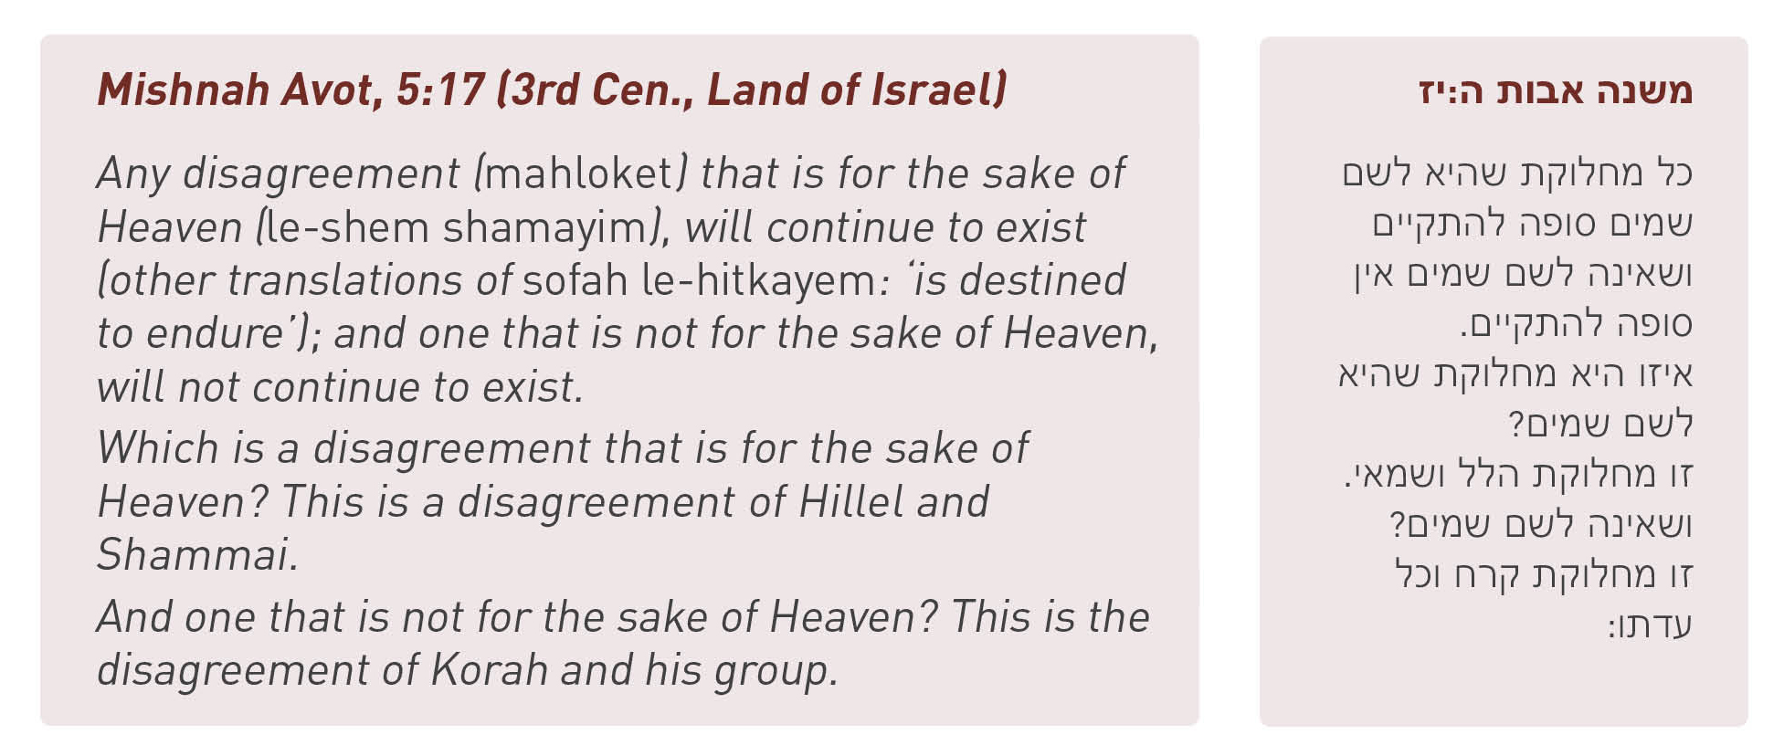

Discussion Question
What is NOT clear from this mishnah?
______________________________________________________________________
Text Study: Meiri, Avot Chapter 5 (text 2.2 and 2.3)

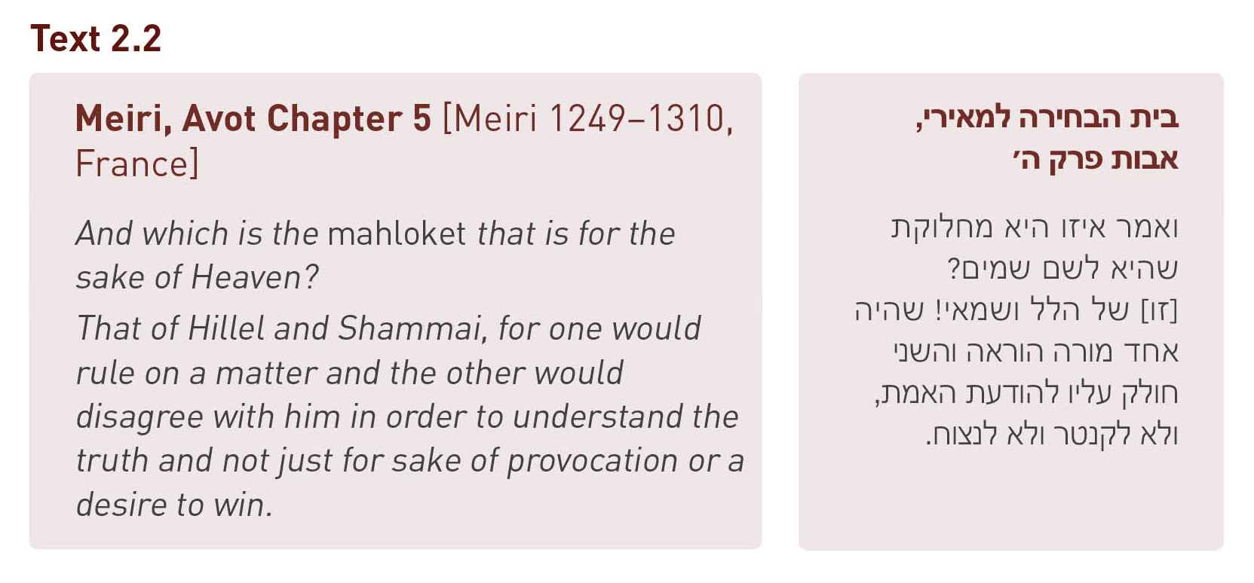
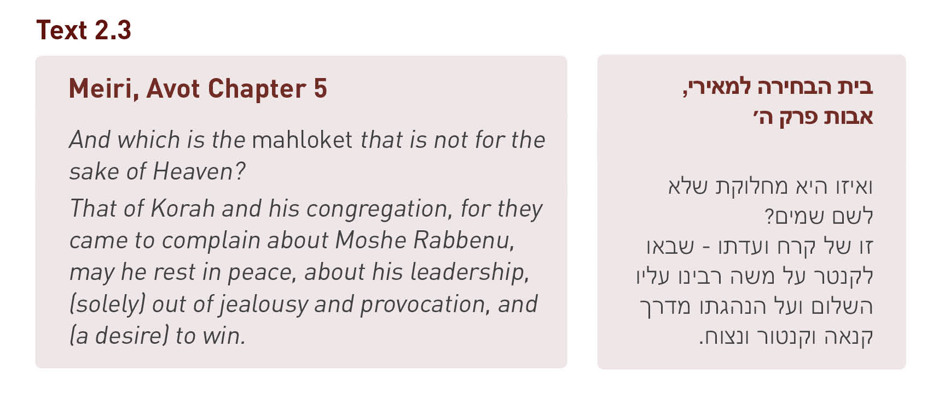
Discussion Question:
Based on the commentary of the Meiri (texts 2.2 and 2.3), how would you distinguish between a mahloket that IS for the sake of Heaven vs. a mahloket that is NOT for the sake of Heaven?
____________________________________________________________

Activity: “Missing the Mark”

Instructions
Read the scenario below and answer the discussion questions.

John is a college student majoring in graphic arts. He applied for a very competitive summer internship at the prestigious design company, ProDesign Inc. Two weeks before his interview for the internship, John received an email from the company informing him that he must create a comprehensive design portfolio and be prepared to present it at his interview.

Rob, John’s roommate and friend, knows how badly John wants this internship. He told Rob several times that this internship could be the key to launching his career in graphic design.

The day before the interview, Rob saw John’s portfolio sitting on the coffee table. He looked closely through every page of his friend’s work. John walked into the living room just as Rob finished looking at the last page of the portfolio. Rob remarked, “Dude, your portfolio looks great! I think it would be even better if you chose a flashier theme and used brighter colors in your drawings.” John’s face turned bright red. He walked straight to his bedroom and slammed the door behind him.

Discussion Questions
- What was Rob’s intention in this scenario, and how did his comments impact John? Could Rob have done anything differently so that his positive intentions would have led to a positive impact?
__________________________________________________________________________________________________________________________________________________________________________________________

- Do you have any examples from your own life - home, school, or community - in which someone did or said something with good intentions but it had a negative impact on you? Can you think of a time when you said or did something with good intentions but it had a negative impact on someone else?

__________________________________________________________________________________________________________________________________________________________________________________________



Based on the video that you watched about the houses of Hillel and Shammai, what are the 4 “pro-tips” that we can learn from them regarding the concept of mahloket le-shem shamayim?

1. ____________________________________________________________
2. ____________________________________________________________
3. ____________________________________________________________
4. ____________________________________________________________

Which of these 4 tips do you think is easiest to put into practice and which of these 4 tips do you think is most difficult to put into practice? Why?
__________________________________________________________________________________________________________________________________________________________________________________________

ACTIVITY: “Making It Mine”

Thinking about what you have learned today, what is one takeaway you want to try, and why? A takeaway can be an idea, a strategy, a tool, or an action step.
__________________________________________________________________________________________________________________________________________________________________________________________

Lesson 3:
Understanding Ourselves & Others

Why is mahloket le-shem shamayim so hard to achieve?
Why are so many disputes destructive instead of constructive?

The Theory of the “Elephant and the Rider” by Dr. Jonathan Haidt
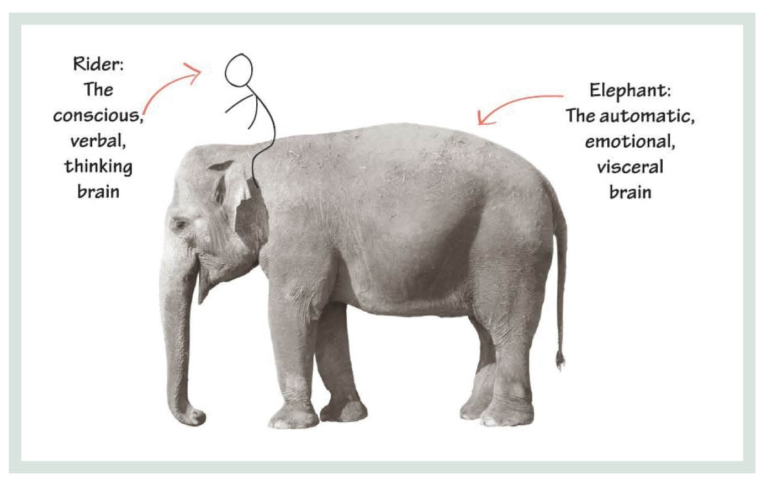
ACTIVITY: “In Sync and Out of Sync”

This is a full group activity. Follow the instructions on the slides that your teacher will display on screen!

Dr. Haidt suggests that a key to understanding our differences can be found in the parallel between human taste receptors and moral foundations/core values:

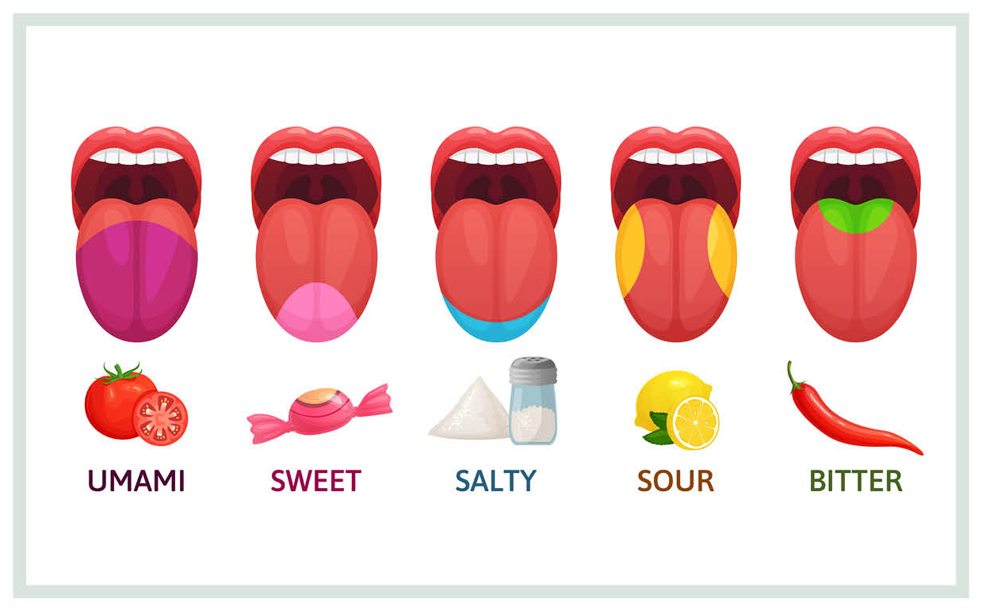

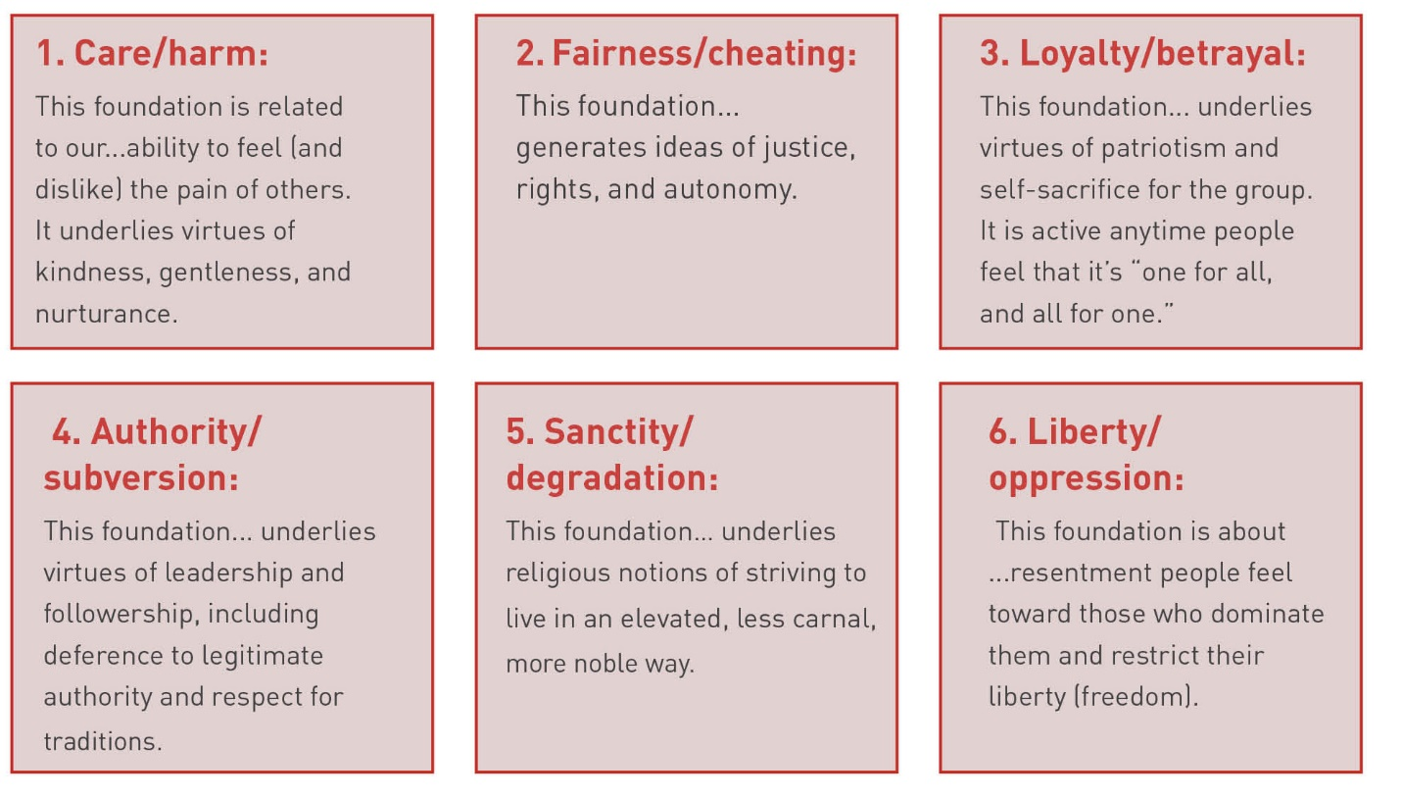

ACTIVITY: “Prioritizing Your Moral Foundations”

Instructions:
- Think about how YOU would prioritize the 6 moral foundations (listed in the graphic above).
- Fill in the “moral foundation pyramid.” Write the moral foundation that is your top priority at the top of the pyramid. Write your second most important moral foundation in the space second to the top of the pyramid, etc.
- Compare your pyramid with one classmate. Discuss how your pyramids are similar and different, and why you chose to prioritize the moral foundations as you did.
- Discuss with your classmate whether you can imagine a scenario that would cause you to prioritize your core values differently in that particular case.

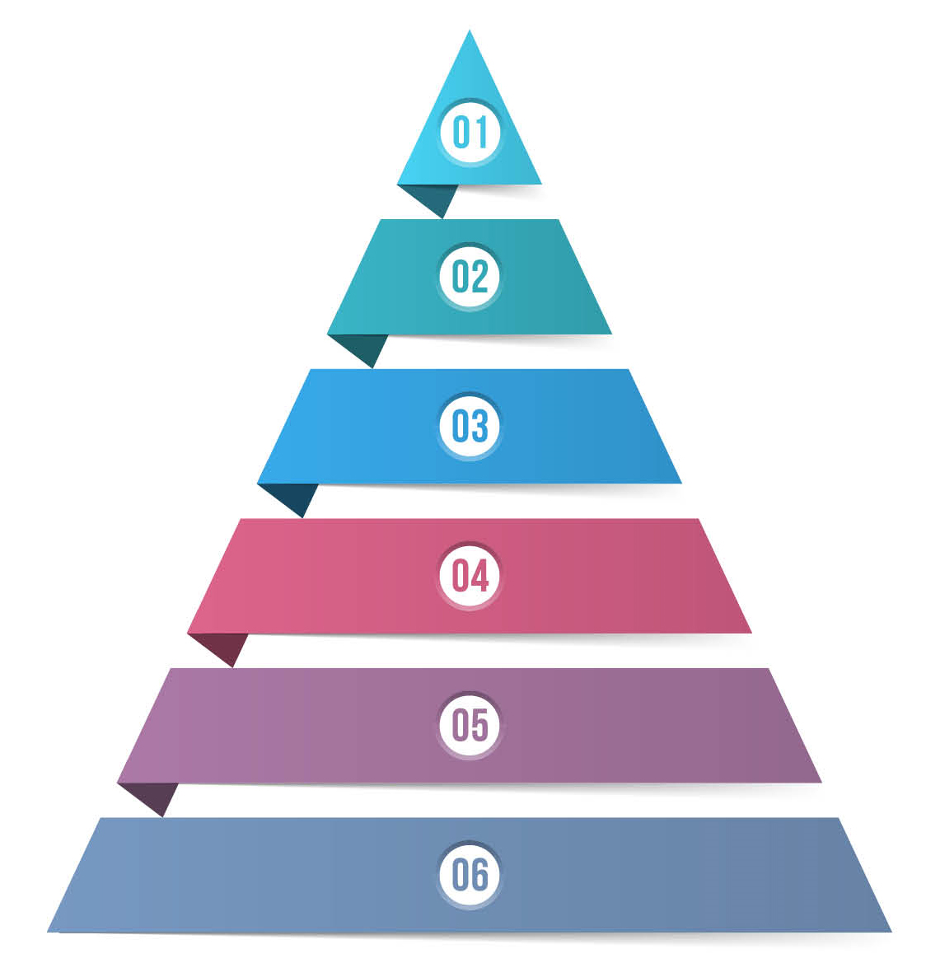

1:

2:

3:

4:

5:

6:

How are different prioritizations of the 6 moral foundations reflected in some of the polarizing issues of today?

Activity: “Hot Topic Headlines”

Instructions:
1. Read the following question but do NOT answer it:
- If Donna’s state was considering revising its welfare policies, which view would Donna be more likely to take?

a) We should be more generous, especially to people raising children.
b) We should be more vigilant about cheaters who are ‘milking’ the system.

Discussion Question
If Donna chose view A, from which moral foundation(s) is she likely drawing?
If Donna chose view B, from which moral foundation(s) is she likely drawing?

__________________________________________________________________________________________________________________________________________________________________________________________

2. Read the following question but do NOT answer it:
- Does Craig believe that it is appropriate to kneel during the US national anthem as a protest against racial inequality in America?

a) Yes
b) No

Discussion Question
If Craig chose view A, from which moral foundation(s) is he likely drawing?
If Craig chose view B, from which moral foundation(s) is he likely drawing?

Instructions: Watch the video of the national anthem ceremony before the San Antonio Spurs and Sacramento Kings basketball game on July 31, 2020.

Discussion Questions regarding the Video:
- What did you notice about the players and coaches during the national anthem?
________________________________________________________

- Did anything in this video surprise you?
______________________________________________________________

Instructions: Please read this Washington Post article from August 3, 2020 titled, “Why not everyone was kneeling during the NBA anthem demonstration.”

Discussion Question regarding the Washington Post article:
1. How does the behavior of the members of the NBA who are mentioned in this article reflect the principles of mahloket le-shem shamayim?
__________________________________________________________________________________________________________________________________________________________________________________________

2. If you had been a member of the NBA when the season resumed on July 30, would you have chosen to stand or to kneel during the national anthem? Why?

__________________________________________________________________________________________________________________________________________________________________________________________

ACTIVITY: “I Am Curious”

Instructions:
- Complete this sentence: “I am curious to learn more about...” or “I am curious about...”
- Take a minute or so to think and write a “note to self” that you will share aloud with the rest of the group.

__________________________________________________________________________________________________________________________________________________________________________________________

