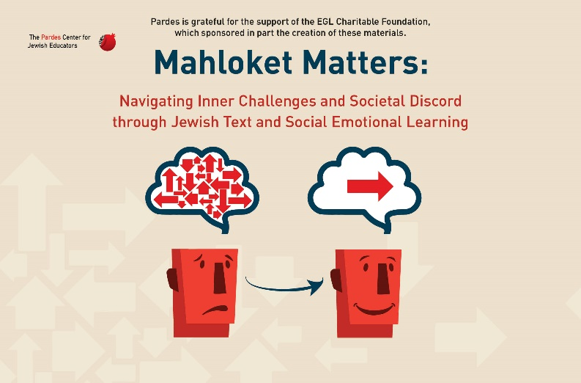

Welcome to Unit 2 of the Pardes Mahloket Matters program!

Unit 2 is called “Showin’ Up!” and consists of the following 4 lessons:

- “The Conversation That Never Happened”
- “Internal Conditions: It Starts With Me!”
- “Interpersonal Conditions: Between You and Me”
- “External Conditions: Setting the Stage”

Each lesson includes Jewish texts, discussion questions, activities, and skill building. By the end of this unit, you will have explored the following essential questions:

- Who or what torpedoed the potential conversation between Moses, Dathan, and Abiram in the Book of Numbers, Chapter 16? (lesson 1)
- What physiological clues can help me identify whether or not my brain is ready to engage productively in a difficult conversation? If I am not ready, how do I become ready? (lesson 2)
- When I am emotionally triggered, how can I re-regulate my nervous system so that I can access reason, empathy, and critical thinking? (lesson 2)
- How can I identify my needs and motivation in order to create a clear and productive intention for engaging in a difficult conversation? (lesson 3)
- How do I craft an invitation to a difficult conversation that is welcoming, honest, and non-aggressive? (lesson 3)
- How might the setting – where, when, how, and who- impact the development or outcome of a difficult conversation? (lesson 4)
Lesson 1: “The Conversation that Never Happened”


ACTIVITY: “Communication Confusion”

1. You are about to see a series of slides. Each slide will feature a phrase or sentence WITHOUT punctuation.
2. Depending on the punctuation and tone in which each of these sentences is read out loud, the sentence will have a very different meaning or connotation.
3. One student will read the sentence out loud with whatever tone/punctuation the student chooses. The rest of us will interpret the meaning of the sentence based on the tone/punctuation you heard when it was read out loud.
4. Another student will read the SAME sentence with a different tone and/or punctuation. After the sentence is read out loud, the rest of us will interpret the meaning of the sentence based on the alternate tone/punctuation.

Text Study: Numbers 16:1-3, 12-15

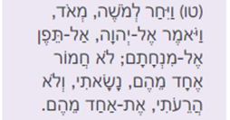



Discussion Questions
1. Based on verse 3, what complaint do Korah and his entourage make against Moses and Aaron?

____________________________________________________________________
____________________________________________________________________

2. What is the ambiguous phrase in verse 12? How does the interpretation of that phrase impact your interpretation of the story?

____________________________________________________________________
____________________________________________________________________

ACTIVITY: “Your Take”

You are an Israelite in the desert with an active Instagram following. You just witnessed Dathan and Abiram refusing to accept the invitation of Moses to meet. You need to update your followers with your take on the latest desert drama!

Please take a photo and create a caption for the photo that captures your understanding of Moses’s intention for reaching out to meet with Dathan and Abiram and their reason for refusing to do so. (You may recruit other actors to appear in your photo!)

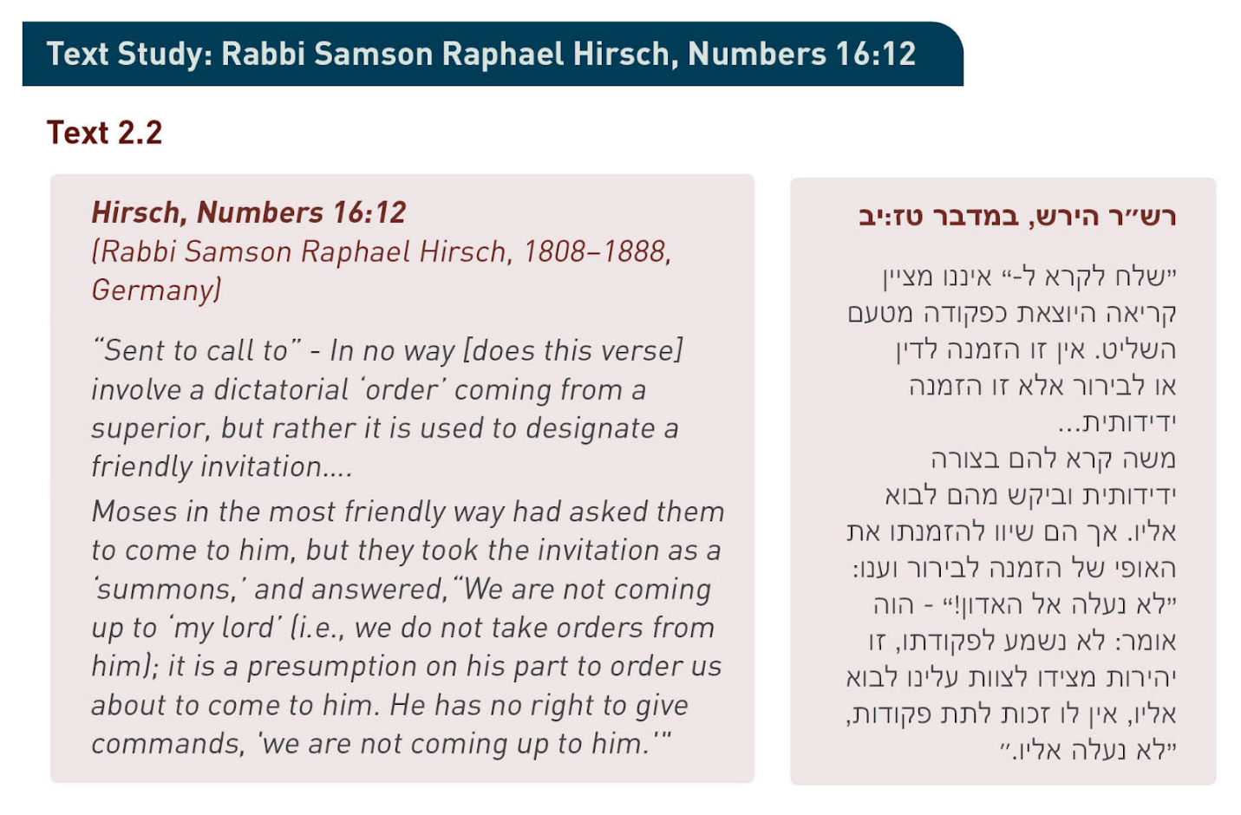
Discussion Questions
1. According to Rabbi Hirsch, what was Moses’s true intention in reaching out to Dathan and Abiram? How did Dathan and Abiram understand Moshe’s request?

____________________________________________________________________
____________________________________________________________________

2. What was the source of this grave miscommunication between Moses and Dathan and Abiram? Would the outcome of the story have been different had the adversaries engaged with each other face to face?

____________________________________________________________________
____________________________________________________________________


WRITTEN REFLECTION:
Thinking about the facts of the story that we do know, write at least one suggestion for how Moses could have handled the situation better and one suggestion for how Dathan and Abiram could have handled the situation better.

Lesson 2: “Internal Conditions: It Starts With Me!”

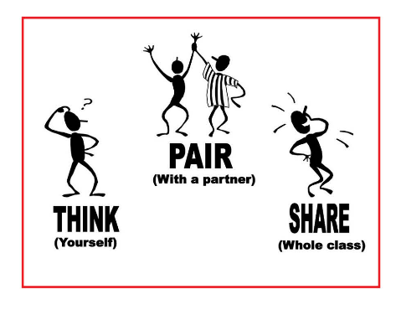
In what circumstances would you decide to show up to a potentially difficult conversation?

In what circumstances would you decide not to show up to a potentially difficult conversation?

THINK: take one minute to think and write down 2-3 circumstances in which you would decide to SHOW UP to a potentially difficult conversation and 2-3 circumstances in which you would decide NOT to show up to a potentially difficult conversation.
PAIR: take 2 minutes to discuss your written lists in small groups of 2-4 students. Students can discuss with their hevrutot in person or in Zoom breakout rooms.
SHARE: designate one person from your hevruta to share 1-2 highlights from your hevruta discussion with the whole group.

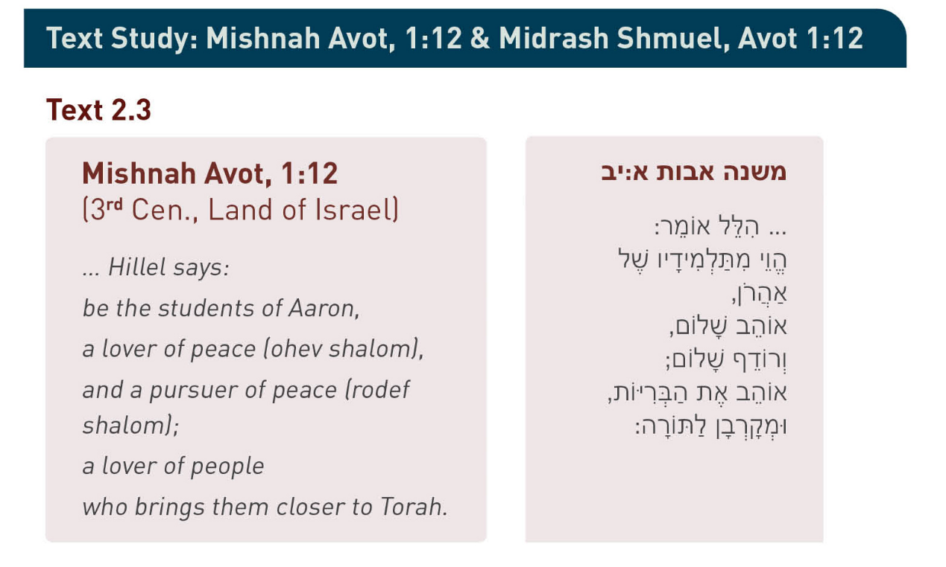
Discussion Questions
1. Why do you think that this mishnah must instruct us to be both ohev shalom (lover of peace) and rodef shalom (pursuer of peace)? What might the difference be between “ohev shalom” and “rodef shalom?”

____________________________________________________________________
____________________________________________________________________

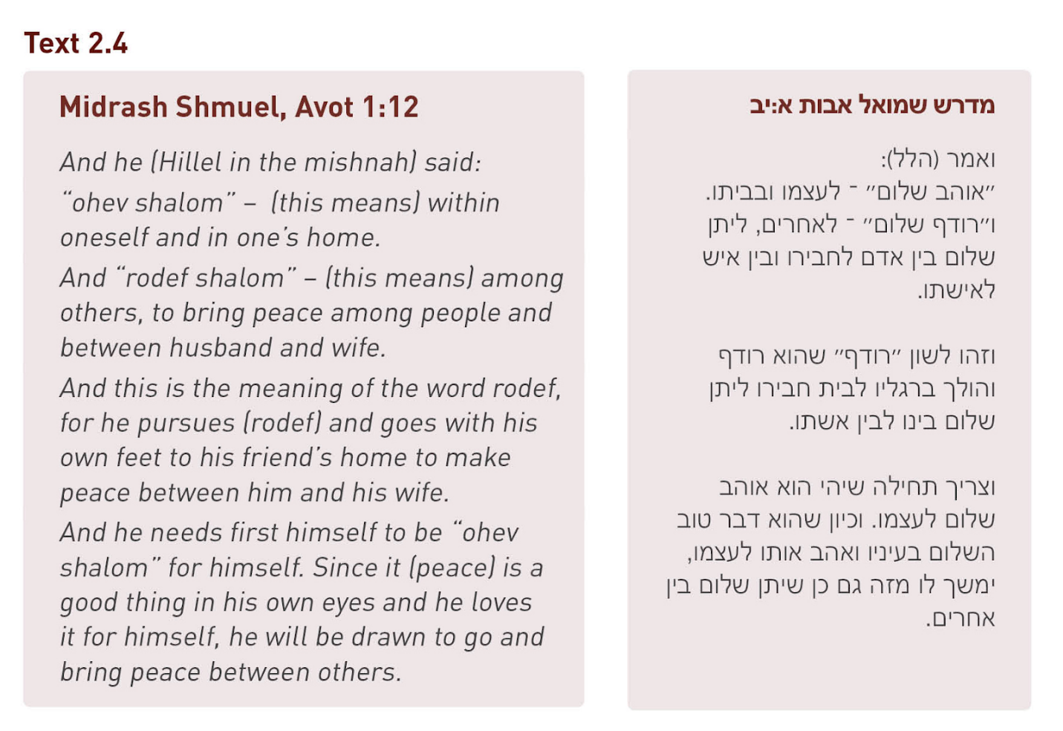
Discussion Questions
1. What is the difference between “ohev shalom” and “rodef shalom” according to the Midrash Shmuel? Is this distinction similar to the distinction you came up with?

____________________________________________________________________
____________________________________________________________________

2. Why does the Midrash Shmuel claim that it is important to be “ohev shalom” before being “rodef shalom?”

____________________________________________________________________
____________________________________________________________________
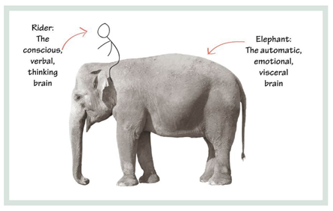

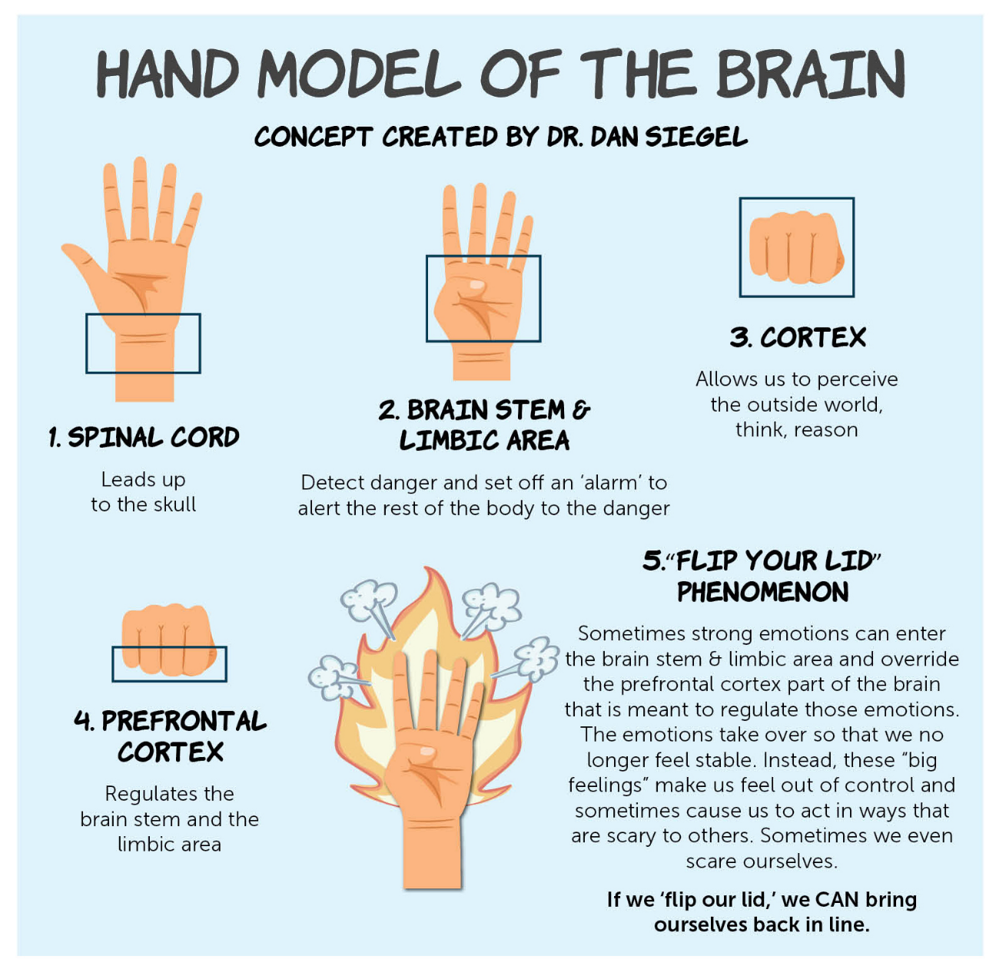
Discussion Questions
1. a) In which part of the brain is the ‘elephant’ found? (label the diagram accordingly)
b) In which part of the brain is the ‘rider’ found? (label the diagram accordingly)

2. Dr. Dan Siegel claims at the beginning of the video that “when we can see in front of us what’s going on in the brain then we can change what the brain does.” Why do you think that visualizing the hand model of the brain during stressful situations has the power to impact what your brain does in that moment?

____________________________________________________________________
____________________________________________________________________

WRITTEN REFLECTION:
a) Please write down an example when you “flipped your lid” during a heated moment and reacted in a way that you may have later regretted.

____________________________________________________________________
____________________________________________________________________

b) Imagine that you had been able to access your prefrontal cortex and responded consciously in that moment rather than reacted to the emotional trigger. What would you have said or done differently?

____________________________________________________________________
____________________________________________________________________

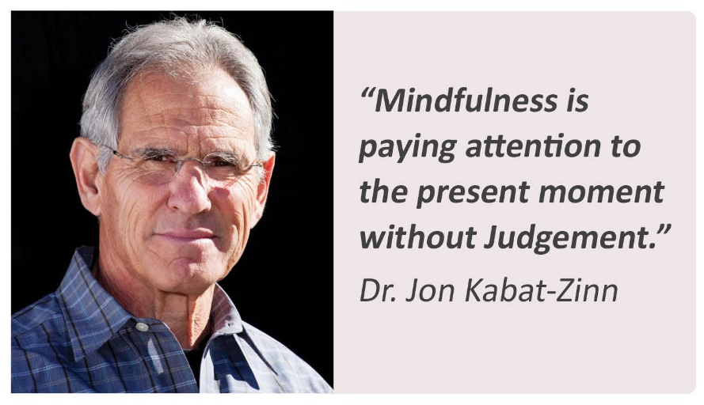

Discussion Questions
1. What do you think it means to pay attention WITH judgement?
____________________________________________________________________
____________________________________________________________________

2. What do you think it means to pay attention WITHOUT judgement?

__________________________________________________________
__________________________________________________________

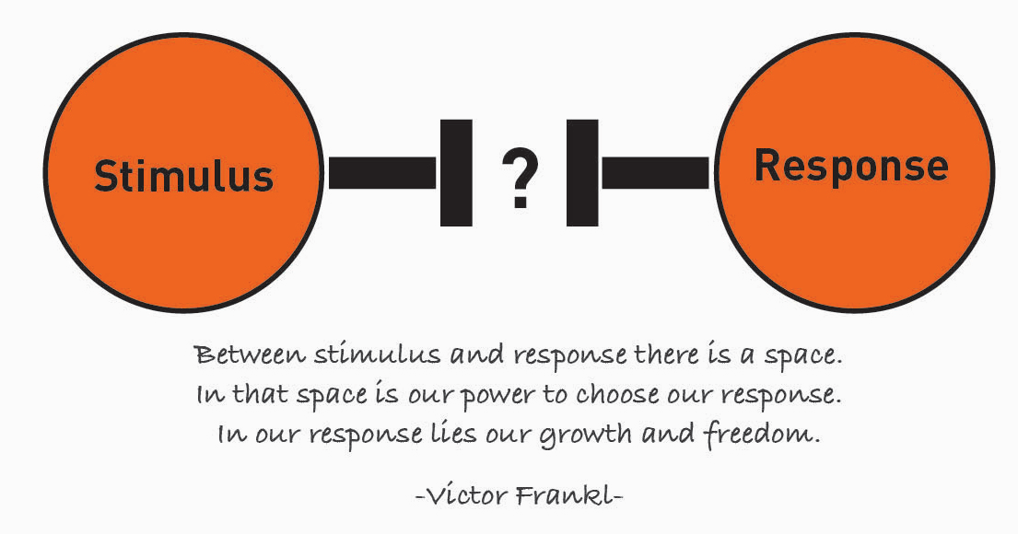



“Just Breathe” – One of the girls in the video compared her brain to a jar that has glitter swirling in all directions. What analogy can YOU come up with for your brain when you feel upset?

ACTIVITY: “Inside - Outside”

- Consider the following emotions:
- Angry
- Sad
- Nervous
- Happy
- Peaceful
2. a) Act out what it feels like in the body when you feel that particular emotion.
b) List some words to describe how each emotion manifests in physical sensations.

____________________________________________________________________________________________________________________________________________

ACTIVITY: “I Used To Think/ Now I Think”

Reflect on what you have learned in lesson 2 by completing one or more of the following sentences:

- I used to think X about my emotions. Now I think Y about my emotions.
- I used to feel X about engaging in a difficult conversation. Now I feel Y about engaging in a difficult conversation.

Lesson 3: “Internal Conditions: It Starts With Me!”

Nonviolent Communication (NVC):
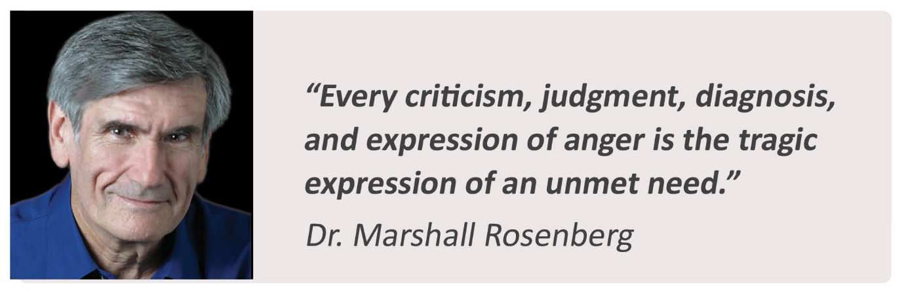

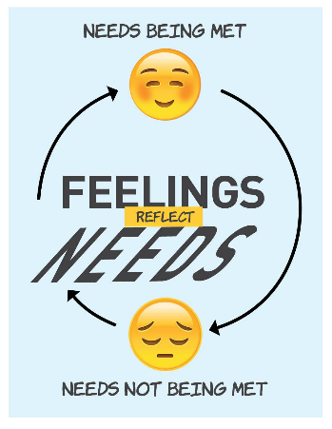

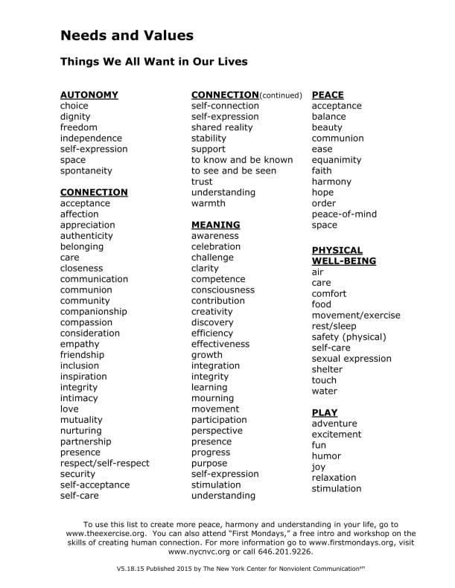

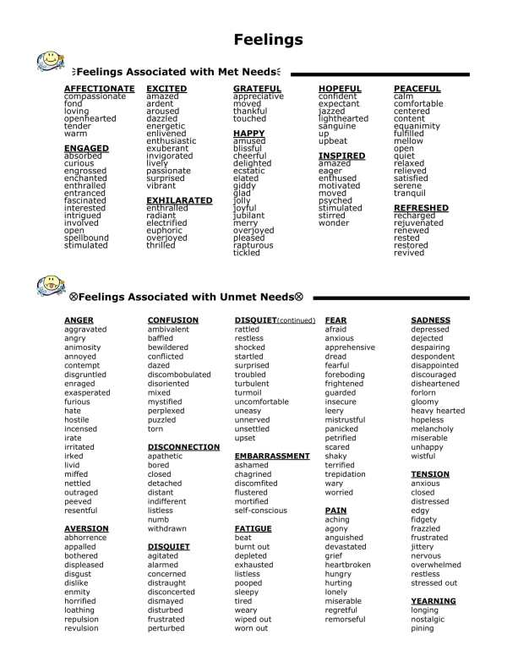

An Example of Negative Feelings that Reflect Needs that have NOT Been Met:


Sivan came home from school and discovered that the handmade vase that normally sits on her desk had shattered all over her bedroom floor, its content strewn everywhere. It turns out that her brother had come into her room to borrow some books and accidentally knocked over her vase in the process.

Sivan felt anger and frustration that her brother had come into her room without permission, which did not honor her needs for space, trust, and security. She also felt remorse and disappointment that the special, handmade vase had broken, because it was helping to fulfill her need for beauty and self-expression in her bedroom.

ACTIVITY: “Matching Feelings With Needs”

What feelings and needs do you imagine might be underneath the surface in the following scenarios?

Scenario A: Your mom comes home late from work, and the house is a mess. She is feeling stressed out and frustrated. What might be a need(s) she has that is not being met?
Scenario B: Your little sister wakes up on the morning of her birthday to breakfast-in-bed and a new bike. She’s thrilled. What might be a need(s) she has that is being met?
Scenario C: The class is going crazy at the end of the school day. How might your teacher be feeling? What might be a need(s) of his that are not being met?

WRITTEN REFLECTION:
Why do you think it would be helpful and important to acknowledge the connection between our feelings and our needs?

____________________________________________________________________
____________________________________________________________________

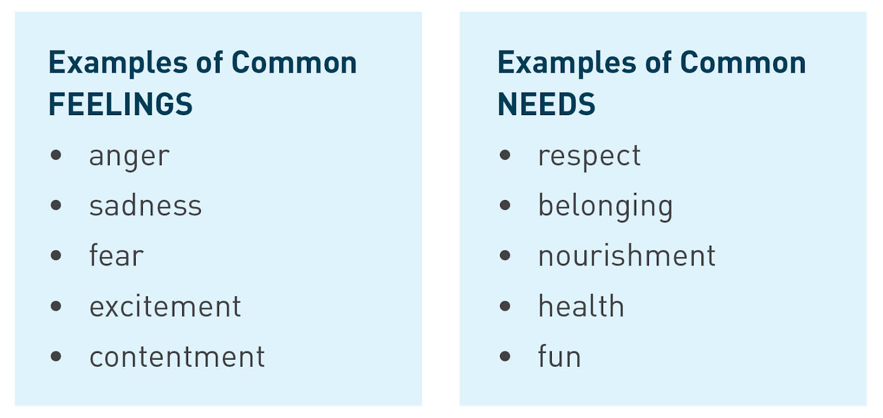

Needs & Strategies In Conflict

Two friends in 12th grade, Joanne and Adam, had a very busy day in school. Both had a math exam in the morning, gave an oral presentation in the afternoon, attended a yearbook meeting during lunch, and ran 3 miles in track club after school. After such a stressful day, Joanne and Adam both have a need for relaxation.

Joanne and Adam sit next to each other on the bus ride home from school. Adam immediately begins filling in Joanne on the details of his crazy day. After 2 minutes, Joanne rolls her eyes, plugs in her headphones, and listens to music the whole way home. Adam is insulted that Joanne tuned him out and decides that he won’t sit next to her on the bus in the future.
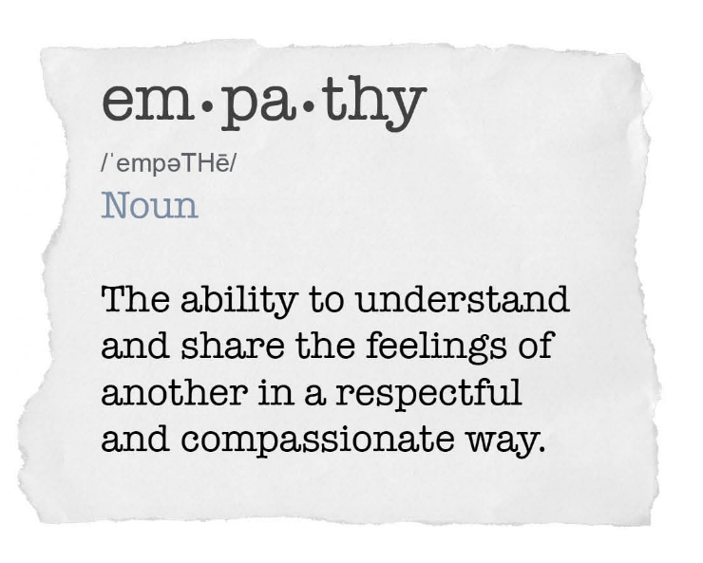

We will consider three examples of empathy in three different contexts: international negotiations, national politics, and home life.

1. The Impact of Empathy in International Negotiations

a) What was the major strategic difference in the way Green Peace approached the Chinese minister vs. the way Yoram Mosenzon approached the Chinese minister?

__________________________________________________________________
____________________________________________________________________

b) Mosenzon claims that people typically begin a conversation by “telling you how you should change rather than starting with empathy.” Why do you think that’s the case?
____________________________________________________________________
____________________________________________________________________

2. The Impact of Empathy in International Negotiations

a) What are the common “American values” that Cox and Peterson say transcend their political differences?

____________________________________________________________________
____________________________________________________________________

b) How is this ad an appeal to the empathy of the American public?

____________________________________________________________________
____________________________________________________________________

c) These two gubernatorial candidates on opposite sides of the aisle joined together to use their campaign platform to demonstrate and encourage civility. How do you think that citizens who are not in the public spotlight can demonstrate and encourage civility in our own circles in-person or on social media?

____________________________________________________________________
____________________________________________________________________

3. The Impact of Empathy in Home Life


Rebecca Schisler, mindfulness educator and co-author of the Mahloket Matters School materials, shares a memory of how empathy transformed an ongoing conflict for her at home:

My step-dad and I hold different political views, and when I was a teenager, we were constantly getting into arguments about it that never really led anywhere and made us both upset. When I began to practice mindfulness and learned about Non-Violent Communication, I focused less on which one of us was ‘right’ and which one of us was ‘wrong.’ I realized that his opinion, and his passionate expression of it, was connected to his underlying needs and past experiences. I didn’t know what those experiences were, or what his needs were, but I knew that I could relate to them- whether they were to be heard, to feel safe, to feel integrity, or even to feel secure in his identity. When I could tune into his feelings and needs and reflect on how they are true in my own life also, I could feel compassion and empathy for him. Then, I was so much more motivated to respond with patience, kindness, and more skillfulness, as I practiced and learned more over time.

Over the years, those political conversations have shifted significantly! We still disagree on some important issues, but we have both opened our minds a bit more to the others’ perspective. The change did not happen overnight, but our mutual understanding and respect for one another has deepened, and our communication has steadily improved.
Discussion Questions:
1. How is it possible to have empathy for someone when you do not know their underlying needs or past experiences?

____________________________________________________________________
____________________________________________________________________
2. How can cultivating empathy towards the other person impact your motivation and intention for engaging in a conversation?

____________________________________________________________________
____________________________________________________________________

ACTIVITY: “Partner Empathy Exercise”
You will be working with a partner for this activity. Both partners should have handy the Needs Inventory and the Feelings Inventory for easy reference.

1. a) Partner A: Share about something that happened recently in your life and how it made you feel (can look at Feelings Inventory for reference).
b) Partner B: As you listen, tune into your own experience of that feeling, remembering a time when you have felt that way in your own life. See if you can feel some empathy for your partner. Try to express that feeling of empathy to your partner either verbally or non-verbally.
c) Partners A and B should switch roles.

2. Working with the same partner, follow the next steps:
a) Partner A: Share about a need that you have in your life (can look at the Needs Inventory for reference) and a time when that need was either met, or not met.

b) Partner B: listen and reflect on if and how that need shows up in your own life. See if you can feel some empathy for your partner. Try to express that feeling of empathy to your partner either verbally or non-verbally.

c) Partners A and B should switch roles.

Thom Bond of the New York Center for Nonviolent Communication (NYCNVC) created an exercise called “Shifting Toward Compassion.” In his own words, here is the goal of the exercise:

I created this exercise so people can have what I call a "Shift.” By that I mean experience a "shift" in what you are thinking about and a shift in how you feel. To understand "shift," I have found it helpful to imagine a line like the one below labeled "Connection Continuum.” On one end is rage, disconnect and violence... on the other is compassion, connection and peace. In any given moment we are all somewhere on this line (many or most of us in the middle somewhere).

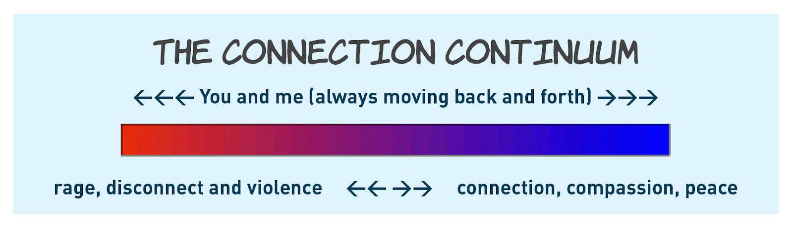

When we interact with other people, we are constantly moving back and forth on this line, often from moment to moment, at times even second to second. This exercise is a tool to move yourself toward a more compassionate state, even in difficult moments.”

ACTIVITY: “The Exercise: Shifting Toward Compassion”

1. Take a blank side of paper and at the top, write down something somebody said to you that you did not like hearing.

Hints:
a) People who choose a less than traumatic, yet "stimulating" situation seem to have greater success early on. Choose a situation that was challenging, but not the most challenging or extreme situation in in your life.

b) Think of the exact quote. No story line or background is needed for this exercise, just the quote.

2. Draw a "T" shape on the top half of the paper and write an "F" on the left side and an "N" on the right, just like in the picture below.
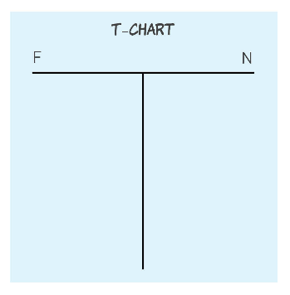
3. On the left side, under the "F" column, write down how you're feeling when you think about that quote. See slide p.14 for a list of FEELINGS to be used with this exercise.
4. On the right side, under the "N" column, write down what you are (or were) needing and not getting the moment you heard the words. See p.13 for a list of NEEDS to be used with this exercise.
5. Take a minute....Close your eyes and relax. After some time, look at the list again. If you feel certain this list represents what you were experiencing then move on to the next step. If you feel like something's missing, go back to the FEELINGS and NEEDS lists and look again until you feel complete.

6. Draw a second "T" shape on the bottom half of the paper with an "F" on the left side and an "N" on the right, just like before.
7. On the left side, under the "F" column, write down what you imagine the other person was feeling when you heard what they said. If you really can't think of what they were feeling, you can try going back to Step 5 and double check your own list. Most people have difficulty doing "Step 7" until their own list is really complete ("Step 5").
8. On the right side, under the "N" column, write down what you imagine the other person was needing and not getting in the moment you heard their words. Just like "Step 7" if you really can't think of what they were needing, you can try going back to Step 5 and double check your own list. Most people have difficulty doing "Step 8" until their own list is really complete ("Step 5").
9. Take a minute. Close your eyes and relax. Look at the list again. If you feel comfortable that this list represents what they were experiencing then move on to the next step. If you feel like something's missing, go back and look at the lists again until you are sure you are complete.
10. Check with yourself and see if you notice a shift in how you feel about what was said to you or how you feel toward the person that said it. Check if you think you may have a way of thinking about this that wasn't there before.... or if you just feel less upset than when you started. If you do, then you've had a shift. You've consciously moved yourself toward compassion. If you feel the same or worse you may want to try again with the same quote or one on a subject that's not as "hot" for you.

Please note: About 20% of people that do the exercise DO NOT shift on the first time through. 100% of people who keep trying eventually do…People who practice this over and over report more success in "shifting.” It's like developing a muscle. Please keep in your mind that this is a "taste" of NVC and there is a larger body of work and practice that is far more powerful when we increase our skills through learning and practice.

Setting a Clear Intention



Crafting and Extending a Welcoming Invitation
Scenario A: Hey, we need to talk! I can’t believe you were so mean that you, John, and Sarah went to that movie without me! You knew I wanted to go to and none of you even thought to invite me.
Scenario B: Hey, I heard you, John, and Sarah went out to a movie. I wanted to see that movie too. I feel left out. Can we talk about it?

Discussion Questions:
1. What are some significant differences between these two invitations to talk?

2. How can cultivating empathy towards the other person impact your motivation and intention for engaging in a conversation?
Tips for Crafting a Successful Invitation
1. It is a request, not a demand! That means we have to accept it if the other person declines the invitation. Do not assume they are available or wanting/ready to engage.
2. The invitation can include your intention. For example:
"I would like to talk to you about the issue of immigration. I want to share where I am coming from and understand better where you are coming from. Are you open to having a conversation with me about this?"
3. Your tone of voice is as important as the words you choose.

Thought Question: How can you clearly express tone through text messaging or social media?
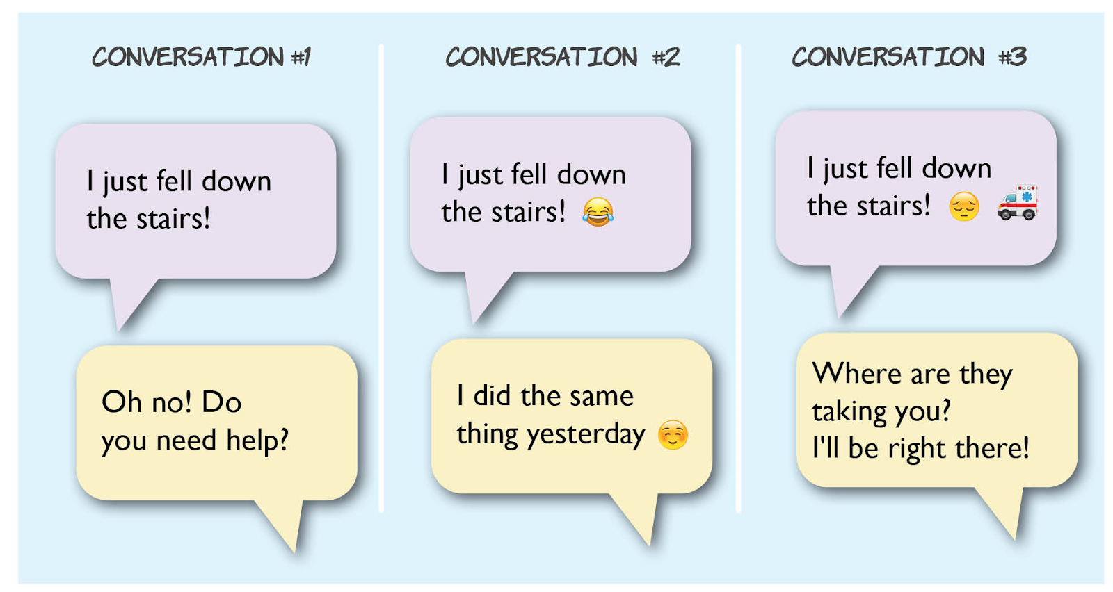

WRITING ACTIVITY:
Pretend you are Moses and you get a chance to rewrite history. You’ve got another shot to extend an invitation to Datan and Abiram to join you in a conversation. What will you say in your invitation?

____________________________________________________________________
____________________________________________________________________
Lesson 4: “External Conditions: Setting the Stage”

Review:
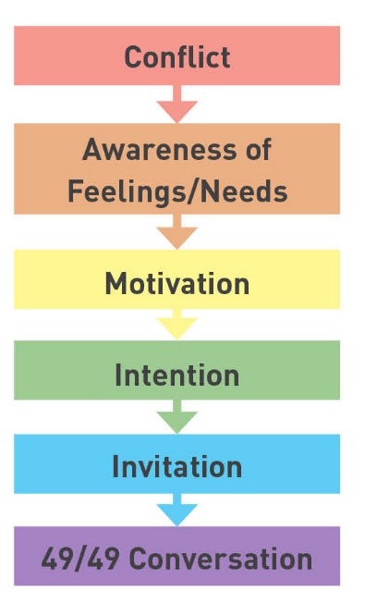

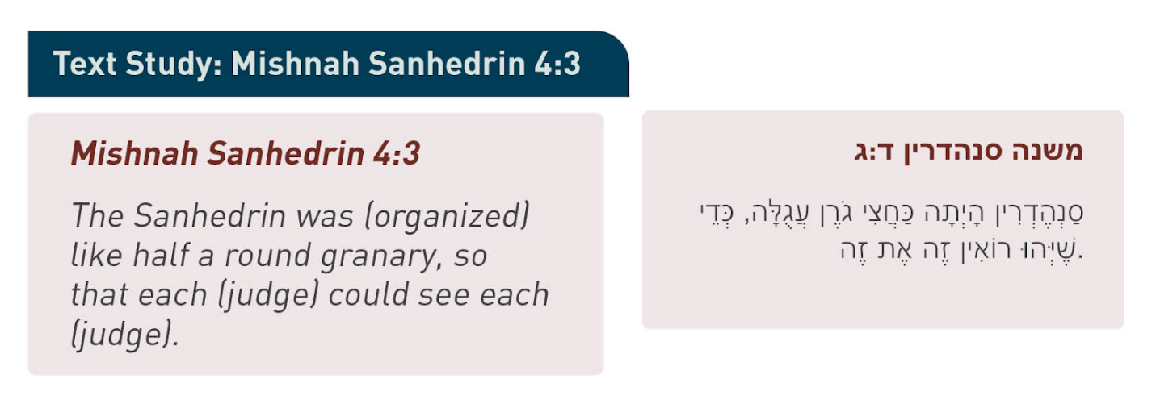

Discussion Questions:
1. What was the seating arrangement in the Sanhedrin? 

2. What is the significance of the judges being able to see each other?

ACTIVITY: “Creating a Vibe”

Consider the following questions upon seeing each of the 3 slides that your teacher displays:
- How was this particular place designed to make you feel?

- What specific features of this place make you feel that way?

Determine the Appropriate Setting for a Conversation

You decide that you want to run for student council treasurer. You share your plan with your friend, Karen. The next week, you see Karen’s name on the official list of student council treasurer candidates. You feel betrayed that Karen is running against you, and you feel hurt that she did not tell you in person. You have decided that you want to talk with Karen about this upsetting situation.

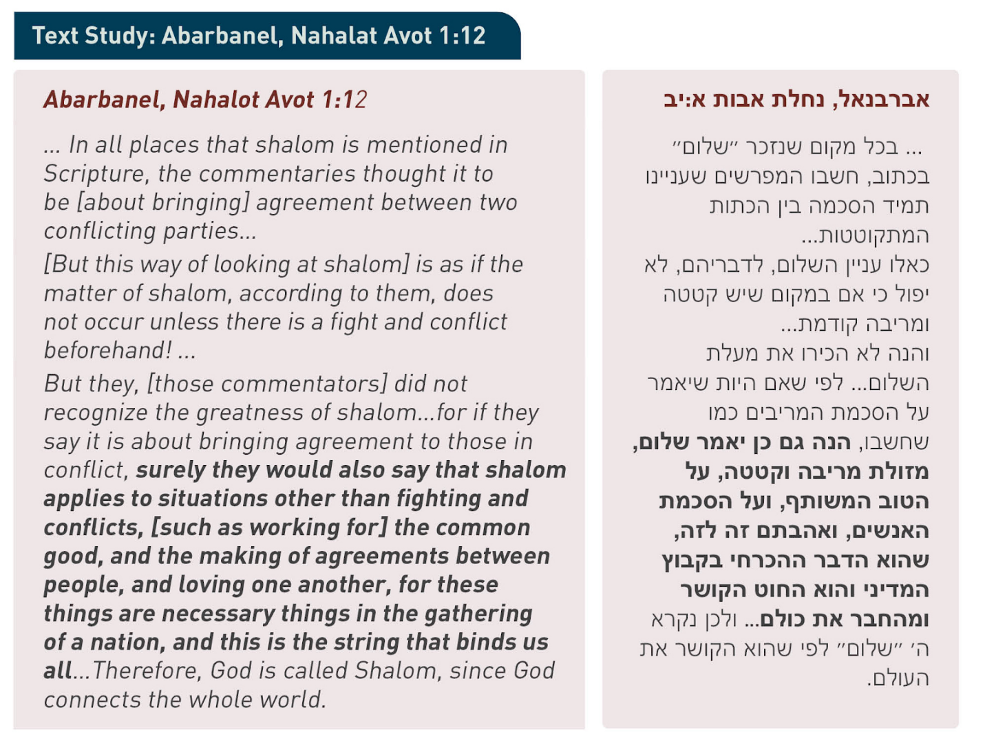

Discussion Question:

1. Why do you think that the Abarbanel includes the “making of agreements between people” in his second definition of shalom?


Rebecca reflects about her experience in 2019 with an Israeli – Palestinian youth program that did not establish any kind of anchoring agreement in advance of the gathering:

Last year, I was observing a program at an organization that brings together Israeli and Palestinian teenagers in Jerusalem for peace-building work. It was right after the Trump administration unveiled a controversial Peace Plan, and tensions were high among everyone in the group. In an effort to promote constructive dialogue, the organization held a session for 9th and 10th graders to learn about the specifics of the plan, and process their thoughts and feelings together.
But there had not been agreements laid out in an explicit or significant way as to how the conversation would take place. While the program leader was trying to present information and facilitate a dialogue, participants continually interrupted her with questions and exclamations. They also interrupted one another, and seemed to be 'talking at' one another rather than listening and responding. Some of them were totally absorbed in their cellphones while those who they disagreed with were talking. After one student expressed his opinion, some others simply got up and walked out of the room. Participants were continually whispering to the people sitting near them, and some were yelling and responding in a blameful tone of voice when others spoke. There was a thick emotional charge in the room, and the atmosphere was one of chaos.

Discussion Questions:

1. Why do you think that the teens in this program acted this way?
2. What are some anchoring agreements that could have made this experience more productive and aligned with a mahloket le-shem shamayim environment?
3. Due to the lack of a mahloket le-shem shamaymim atmosphere, what opportunity was lost in this gathering of Israeli and Palestinian teenagers?

ACTIVITY: “Creating a Classroom Haskamah (Agreement)”

1. In small groups, come up with 3-5 classroom community agreements that are important to you. Have a scribe take notes in each group.
2. The agreement statements should be simple to remember and concise. They may also be descriptive but fit into simple categories or values. For example, the category of RESPECT may contain the statement, “Do not interrupt people.”
3. Each small group will have a chance to share with the whole class the 3-5 anchor agreements that they came up with.
4. After hearing the ideas of each small group, the class decides together on our 3-5 official haskamot. Everyone’s consent matters!
5. Let’s discuss what to do if someone breaks the haskamah.

6. Decide where this classroom haskamah will reside for easy reference (e.g., hang it on the classroom wall, document in a shared classroom folder, etc.)

ACTIVITY: “Sharing Circle”

- Share a challenge - personal, interpersonal, or societal - in your life that is in process right now.
[It does not have to be the deepest, hardest thing you’re dealing with! Just something that is challenging, where there might be potential for mahloket le-shem shamayim or learning.]
2. Share a challenge you have had in the past that was resolved in a constructive or meaningful way and had a positive impact on you in the end. What did you learn from that experience?

Reminder: We are hear to listen to each other, not to give advice. You are welcome to to use hand signals to communicate empathy and presence (e.g., rub thumb and forefinger together to indicate “same here!”).

