Never Pharaoh! vs Pro-Pharaoh!
Time to #BreakTheEchoChamber

Havruta A – Never Pharaoh!

- Watch Pharaoh’s inauguration speech as an anti- Pharaoh demonstrator
שמות פרק א  (ח) ויקם מלך חדש על מצרים אשר לא ידע את יוסף:  (ט) ויאמר אל עמו הנה עם בני ישראל רב ועצום ממנו:  (י) הבה נתחכמה לו פן ירבה והיה כי תקראנה מלחמה ונוסף גם הוא על שנאינו ונלחם בנו ועלה מן הארץ: (יא) וישימו עליו שרי מסים למען ענתו בסבלתם ויבן ערי מסכנות לפרעה את פתם ואת רעמסס: (יב) וכאשר יענו אתו כן ירבה וכן יפרץ ויקצו מפני בני ישראל: | Exodus 1:8-12  8. A new king arose over Egypt who did not know Joseph. 9. And he said to his people, “Look, the Israelite people are much too numerous for us. 10. Let us deal shrewdly with them, so that they may not increase; otherwise in the event of war they may join our enemies in fighting against us and rise from the land (lit. go up from the land).” 11. So they set taskmasters over them to oppress them with forced labor; and they built garrison cities for Pharaoh: Pithom and Raamses. 12. But the more they were oppressed, the more they increased and spread out, so that the [Egyptians] came to dread the Israelites.

- Read the commentary about his speech

Anchor Bible, Exodus 1:10 (W. Propp, 1999. p. 132)
1:8 “New King”: “There arose a king that did not know Joseph" would have sufficed. Why a “new king”? …The “new king”, like the “new wife” (of Deut. 24:5), has not been king for very long. His headstrong action would exemplify the folly of youth upon attaining power (cf. I Kings 12:1-19).
1:9 “his people… people of Israel’s sons”- … There may be… an effort to balance the “people" of Israel against “ammo” his [Pharaoh’s] people, to emphasize that the conflict is between two sovereign nations.
“Greater and mightier than us”: … Thus 1:9 makes the historically preposterous claim that the Israelites became more powerful than the Egyptians… Pharaoh’s paranoia is ludicrous, yet sinister. Demagogues often credit weak minorities with vast powers. Elsewhere, the Bible depicts the Egyptian ruling class as obsessively xenophobic (Gen. 42:9, 12; 43:32; 46:34). Egyptian sources attest to their tight control on immigration and emigration.
1:10 “Go up from the Land”:
We might expect the Egyptians to fear that Israel would conquer the land. But I am not sure we can or should rationalize Pharaoh’s concerns…

- Tweet your impressions of Pharaoh’s inauguration speech including his character, motives and fears:

Havruta B - Pro- Pharaoh
- Attend Pharaoh’s inauguration speech as a pro-Pharaoh supporter
שמות פרק א  (ח) ויקם מלך חדש על מצרים אשר לא ידע את יוסף:  (ט) ויאמר אל עמו הנה עם בני ישראל רב ועצום ממנו:  (י) הבה נתחכמה לו פן ירבה והיה כי תקראנה מלחמה ונוסף גם הוא על שנאינו ונלחם בנו ועלה מן הארץ: (יא) וישימו עליו שרי מסים למען ענתו בסבלתם ויבן ערי מסכנות לפרעה את פתם ואת רעמסס: (יב) וכאשר יענו אתו כן ירבה וכן יפרץ ויקצו מפני בני ישראל: | Exodus 1:8-12  8. A new king arose over Egypt who did not know Joseph. 9. And he said to his people, “Look, the Israelite people are much too numerous for us. 10. Let us deal shrewdly with them, so that they may not increase; otherwise in the event of war they may join our enemies in fighting against us and rise from the land (lit. go up from the land).” 11. So they set taskmasters over them to oppress them with forced labor; and they built garrison cities for Pharaoh: Pithom and Raamses. 12. But the more they were oppressed, the more they increased and spread out, so that the [Egyptians] came to dread the Israelites.

- Read the commentary about his speech
Book of Jubilees chapter 46, 200 BCE (G-d is talking to Moses)
5. And he (Joseph) commanded the children of Israel before he died to carry his bones at the time when they would go out of the land of Egypt. And he made them swear an oath concerning his bones because he knew that Egypt would not again bring them forth and bury them in the land of Canaan because when Makamaron, the king of Canaan, was dwelling in the land of Asshur, he fought in the valley with the king of Egypt. And he killed him there. And he pursued after the Egyptians as far as the gates of Ermon. And he was unable to enter because another new king ruled Egypt and he was stronger than he. And he returned to the land of Canaan and the gates of Egypt were shut up and there was none who could leave or enter Egypt. And Joseph died in this forty- sixth jubilee in the sixth week in the second year. And they buried him in the land of Egypt. And all of his brothers died after him. 9. And the king of Egypt went forth to fight with the king of Canaan in this forty-seventh jubilee in the second week in the second year. And the children of Israel brought forth the bones of the children of Jacob, all except the bones of Joseph. And they buried them in the field in the cave of Machpelah in the mountain. And many returned into Egypt but a few of them were left in Mount Hebron. And Amram, your father, was left with them. 11. And the King of Canaan was victorious over the king of Egypt and he closed the gates of Egypt. And he [King of Egypt] conceived an evil thought against the children of Israel so that he might cause them to suffer. And he said to the men of Egypt, “Behold, the people of the sons of Israel have grown and increased more than we. Come let us act wisely concerning them before they increase. And let us cause them to suffer in slavery before war comes to us, or before they battle with us, or if not (that, then) they will mix with our enemy. And they will depart from our land because their hearts and their faces are upon the land of Canaan.” And they appointed over them taskmasters to make them suffer in slavery. And they built strengthened cities for Pharaoh, Pithom, and Ramses. And they built all of the walls and all of the ramparts which had fallen in the cities of Egypt. And they made them slaves by force. And to the extent that they acted cruelly against them, they likewise increased and multiplied. And the men of Egypt regarded the sons of Israel as defiled.

- Tweet your impressions of Pharaoh’s inauguration speech including his character, motives and fears:

Instructions

Step 1 (7 min.): Break into groups of 4, and then have each group split into two havrutot: havruta A and B..

Havruta A – you are advocates for the Never Pharaoh movement that just watched the Pharaoh Inauguration speech. Read the verses from Exodus chapter 1, 8-12 and then read the Anchor Bible Commentary (brought on the next page) and write a tweet (140 characters) of how you see Pharaoh, his motivations and fears.

Havruta B – you are Pro- Pharaoh advocates that just attended his inauguration speech. Read the verses from Exodus chapter 1: 8-12 and then read the Book of Jubilees (brought on the next page) and then write a tweet about how you see Pharaoh, his motivations and his fears.

Step 2 (3 min) : After each havruta has written their tweet share your tweet with the other havruta and prove why your tweet is a reflection of the real facts.

Step 3: Ask all Never Pharaoh havrutot to share their tweets, and then ask all Pro-Pharaoh’s to share their tweets. Then discuss how each havruta when only reading one commentary may not ever notice the ambiguity of the text (why new king real fear of outside enemy or not, real fear of Israelites joining them or not, the wall…).

Incourage students to read contradictory news and us #BreaktheEchoChamber and @9adarProject.

http://www.9adar.org/resource/time-to-breaktheechochamber-read-contradictory-news/)

For further reading: Xenophobic Demagogue or National Savior?!
Can We Discuss This Constructively?

Short Article:
http://elmad.pardes.org/2016/12/xenophobic-demagogue-or-national-savior-can-we-discuss-this-constructively/
Source Sheet:
http://elmad.pardes.org/wp-content/uploads/2016/12/9Adar_Xenophobic-Demagogue-or-National-Savior-1.11.17.pdf

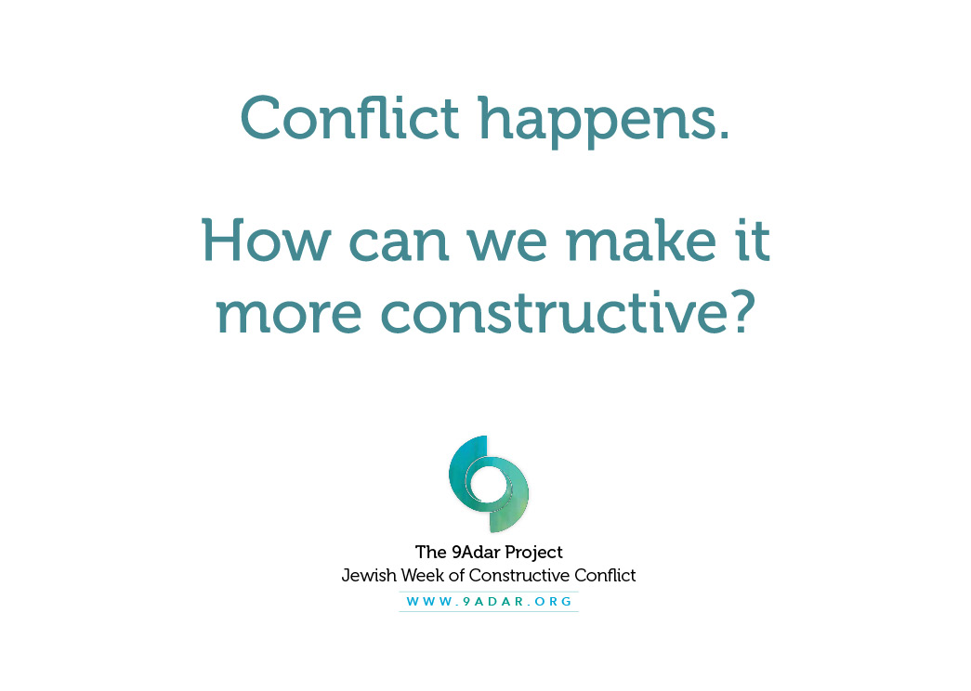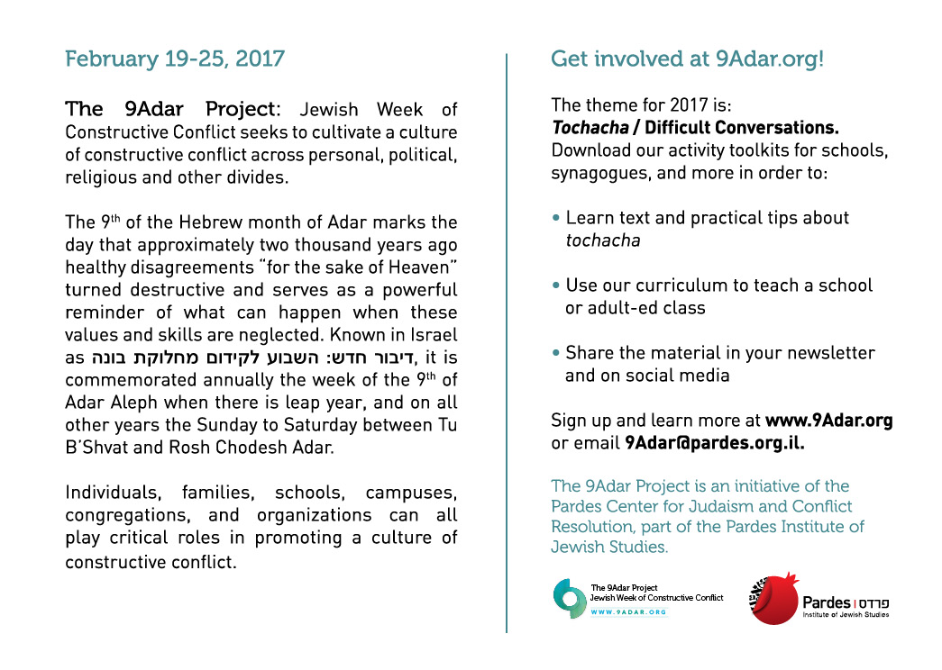
Download our toolkits at www.9adar.org/get-involved. 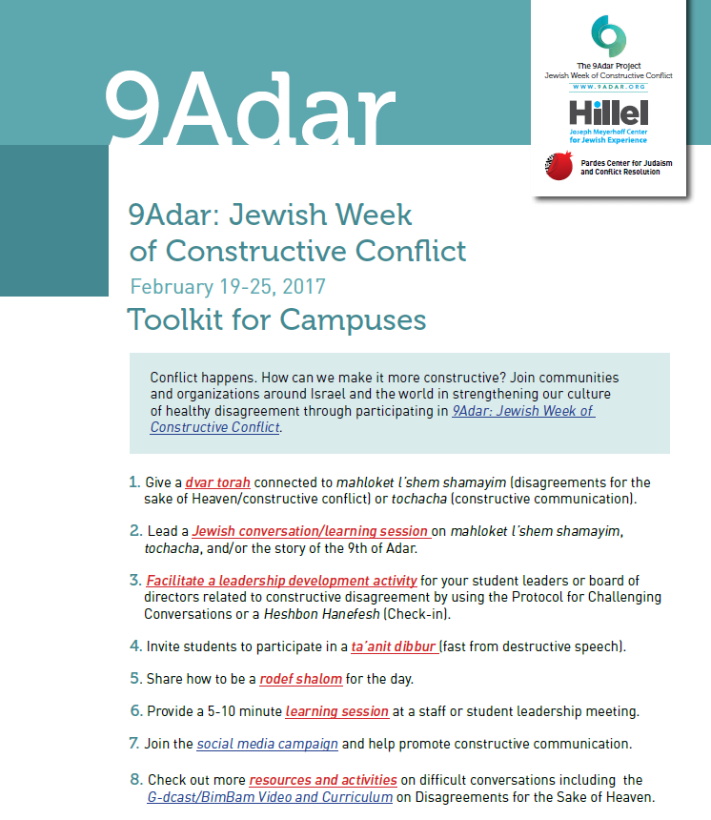
For more information and to share your 9Adar plans, email 9Adar@pardes.org.il.
The 9Adar Project is an initiative of the Pardes Center for Judaism and Conflict Resolution,
part of the Pardes Institute of Jewish Studies (www.pardes.org.il).

